3/18/2017
Munirah M. Alrushud
Saudi e-university
Around The world
For Travel and Tourism Services
Around the world service’s functionality:

Provides choices for customers in many different cities:
This function can provide helpful way that helps the customer by showing them many perfect choices, and cities with the highest rate.
Provides the best deals and prices all over the world:
We always care for hotels’ deals and many different places to provide the best services and the best deals for customers, they’ll get a comfortable service with simple way.
Focus on high-demand destinations:
We give a special care for the high and most used places, hotels, and other services in the main page, so the customer can reach it easily, and to show the customers the reviews from other customers.
Offers the easiest way to book and deal with hotels:
Around the world services care in dealing with large dimension and places that customers are interested on. Deal with big range in different countries to provide the best and wide service to satisfy the needs of all kind of customers.
Around the world website design:
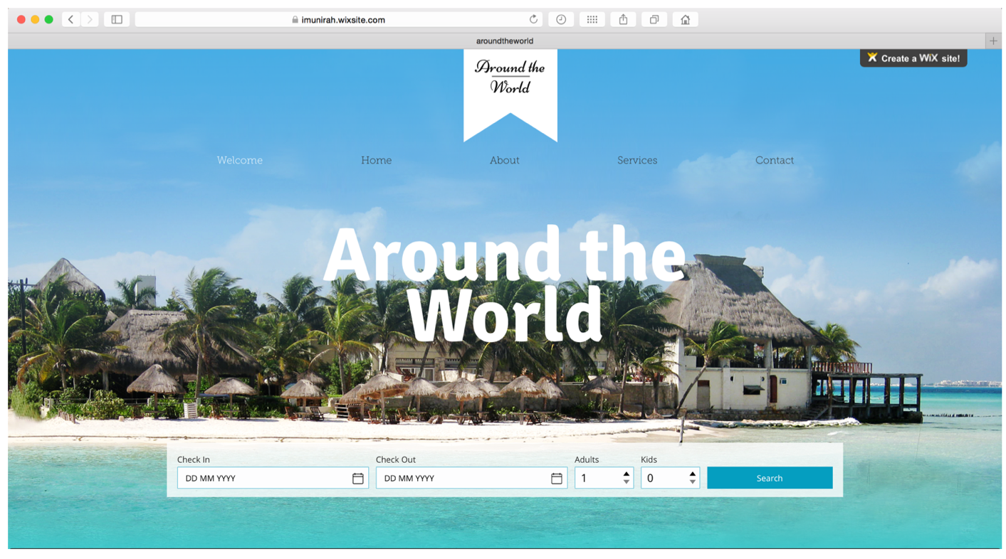

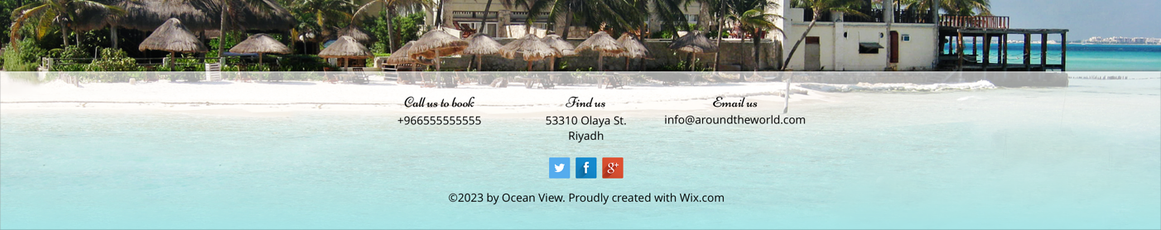
Social media links:

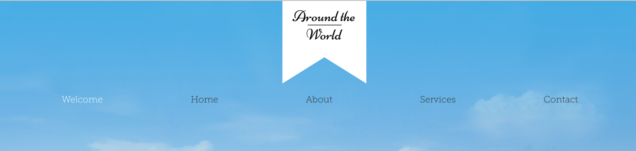
Menu selection:
Functionality Needed:
Clear user interface:
The website should be clear and simple to deal with. Because there are many different types of customers most enter the site and deal with it. It should satisfy the need of all users and customers.

Contact Information:
The most important business detail is contact information, it should be visible and accessible. Customers need to be able to contact and to get in touch with a business or service’ needed.

Clear navigation:
Clear navigation is one of the most important part in the website. The navigation most be easy-to-understand or logical names for all the pages of your site.

Security:
When selling anything online, you need to put some interest into securing your site. we need to encrypt communications between the seller and customers (the credit card number, Social Security number, and so on).

Social media integration:
Twitter, Facebook, Google Plus, LinkedIn, Instagram, and more platform are important. Adding all these platforms into your website will help to improve your business.

The Hardware and Software Needed:
As it known, our services are provided online so there’s not much hardware needed in this business.
We must provide several computers or PCs for all employees and team members.

Web servers:
can be a hardware or software (computer or computer application) helps to transfer content through the internet.

Browsers:
Helps to display the web page in the internet. Like Safari, Google chrome, windows explorer, and more.

Database:
Database system will store the users’ information such as password, name, address, email, and other information to the database.

Types of Security Needed:
Security is determined as the most important part in online store or services. It should be because the website most be entered by any person in anywhere. There are many factors that cause a threat to the website, and other threats such as viruses, hacking, and many of the unlimited threats can face the website and the online companies. Also, we must consider the Authorization and the integrations:

All These Parts Must Be Considered in Developing The Website:

Integrity:
To make sure that the information is displayed in the website and transmitted over the internet and not altered by unauthorized person.

Authorization:
Identify the users or customer identity and their limitation of access, to protect the information so the users not able to access to the personal information of other customers.

Privacy:
Control the use of the customers’ information and allow the customers to schedule themselves. And to express themselves selectively

Availability:
Make sure that the e-commerce website continues to function as what intended or planned to.
Confidents:
Allow the authorized customers to view the message and data that is available for them only not others.

Payment:
The electronic payment should be secure, and we must ensure that we commit the payment for the services over the internet with high security and protection.

“CAPTCHA”:
Considering the CAPTCHA (Completely Automated Public Turing test to tell Computers and Humans Apart) is a type of challenge-response test used in computing to determine whether the user is human or not by using “I’m not robot” in the registration.

The Potential Threats:
Potential threats include

There are many threats are threatening the website such as viruses, worms, Trojan horses, and more. With the unwanted programs such as adware, spyware, and so on. These programs are a security threat that appears when programs are installed on your computer without any acceptance from the users.

Lose of marketing and deals in some places, these losses may alienate customers to other companies or cut off the dealings with our company.

In addition, there’s also a common security threats such as: Cypervandalism, data breach, credit card fraud, spams, etc. The competitors and the Seasonal demand are some threats might face the company, with the economic issues as well.

Recommendations:

Hire an outsourcing or a perfect security team to lead the security and to handle the threats. Dealing with a large number of hotels and tourist places. Offering attractive prices to customers and adding them to the VIP list. Provide many offers and discounts to avoid the Seasonal demands and competitors.

Payment security issues and threat. Is one of the most important threats need to be consider. The customers will add their visa or their credit cards into the website and we most protect their information and their money as well by securing the information.
Make sure to add recommendation space to allow the customers to add their recommendations, to improve our services.

